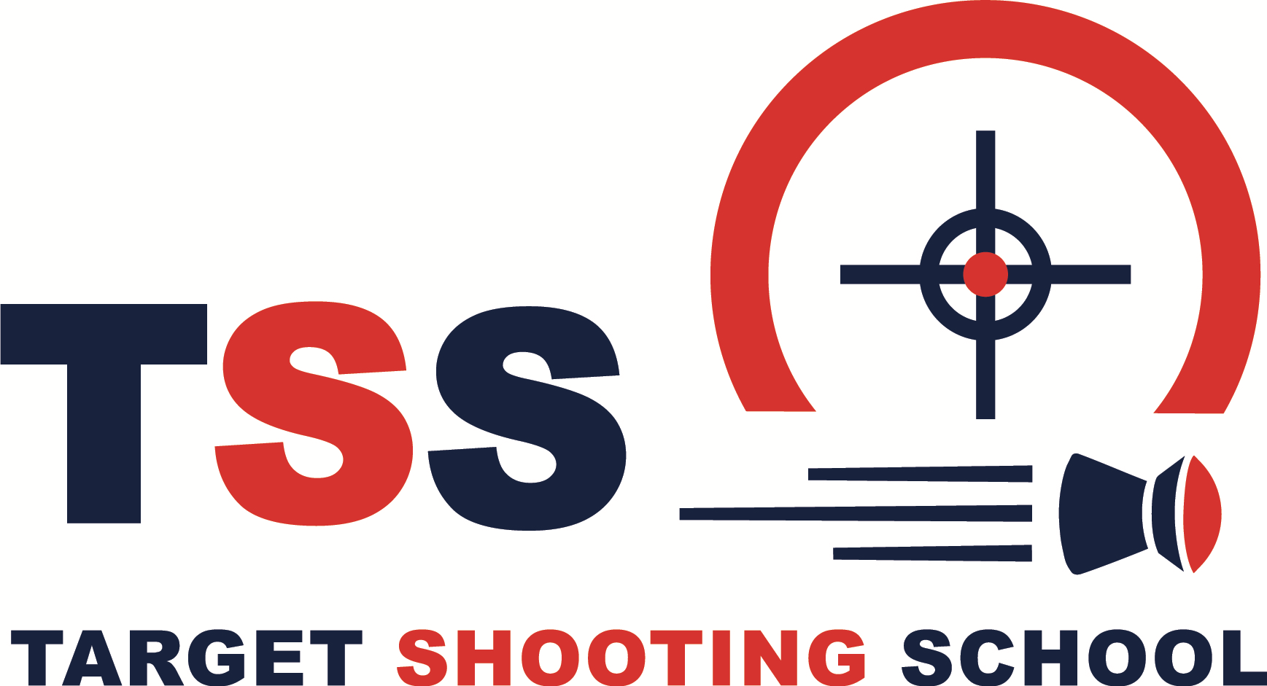
First Name:
Last Name:
Position Applied For: | Instructor/Class Leader
Date of Birth
Mobile No:
Home No:
Email address:
Address:

DBS held: | YES/NO
DBS Number:
DBS Held By:
How did you find out about Target Shooting School?
Current work/previous jobs:

Do you have any experience teaching or instructing? Qualifications?
What experience/work have you had with children? Please give details, especially regarding neurodivergent children.

What benefits do you think youngsters get from learning target shooting?
Do you have any shooting experience?
Qualifications?

Which classes would you like to be part of? | Please add any other notes of your own:
Hothfield Village Hall, Ashford  Mondays 1630 - 1930 | Yes/No
Hildenborough Village Hall  Wednesdays 1630 - 1930 | Yes/No
Sanderson Hall, St Pauls Cray  Fridays 1730 - 2030 | Yes/No
Sevenoaks Weald  Saturdays 0830 - 1130 | Yes/No
Sevenoaks Weald  Saturdays 1100 - 1330 | Yes/No
Would you be able to help during Friday, or other week day, afternoon hours from midday 1330 - 1630 | We sometimes work in schools that run afternoon activities.  Yes/No
Would you be interested in helping conduct summer camps and other workshops during school holidays?

